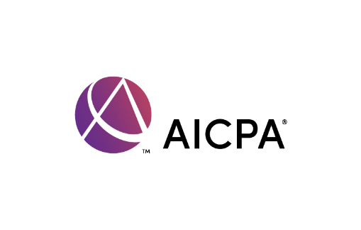

Call to action: U.S. Senate pass H.R. 5119 (as passed by the U.S. House) before the end of the year

Background

The beneficial ownership information (BOI) reporting requirement is an anti-money laundering initiative enacted through the Corporate Transparency Act in 2021. The Financial Crimes Enforcement Network (FinCEN) is a division of the U.S. Treasury Department which will begin requiring small businesses (business earning less than $5 million in gross receipts and fewer than 20 full time employees) including small CPA firms to report information on the “owner” of an entity beginning in 2024. Existing small businesses, formed before December 31, 2023, have one year to file — the filing deadline for these small businesses is January 1, 2025. Small businesses formed in 2024 have 90 days to file, and those formed after 2024 or those making corrections/changes to their filing must do so within 30 days. For more information see the AICPA’s resource landing page by visiting this link: AICPA BOI Resource Page.

On Tuesday, December 12, the U.S. House of Representatives passed legislation that would provide for a one-year delay to this rule (H.R. 5119, introduced by Representatives Zach Nunn, Iowa and Joyce Beatty, Ohio). Now, the U.S. Senate must take up this bill by December 31 or small businesses and the financial professionals who serve them will be working to navigate this new reporting requirement without clear guidance from FinCEN.

Message

Call your two U.S. senators and urge them to pass H.R. 5119 as passed by the U.S. House of Representatives before the end of the year!

Find your U.S. Senators

You can find your two U.S. senators here: https://www.senate.gov/senators/senators-contact.htm.
Washington’s U.S. senators:
Senator Maria Cantwell: (202) 224-3441
Send a letter to Senator Cantwell: https://www.cantwell.senate.gov/contact/email/form
Senator Patty Murray: (202) 224-2621
Send a letter to Senator Murray: https://www.murray.senate.gov/write-to-patty/

To contact your member of Congress via phone call

- Find your senators’ Washington, DC office phone numbers above or on their websites.

- Identify yourself as a CPA and as a voting constituent of the senator. You may be asked to share your email or street address so they can verify your residency in your home state.

- Tell the staff person you are calling to discuss your concerns with the FinCEN (pronounced fin-sen) beneficial ownership reporting requirements which begin on January 1. Tell them you would like the Senate to take up the H.R. 5119 as passed by the House of Representatives on Tuesday, December 12 which would provide financial practitioners a one-year delay to help small businesses better understand their reporting requirements.

Some additional talking points you may choose to use

- I am calling to discuss my concerns with the FinCEN (pronounced fin-sen) beneficial ownership reporting requirements

- The FinCEN rule goes into effect on January 1, 2024. Many small businesses do not know this filing requirement will impact them beginning in 2024. We are deeply concerned that the small business community will not be ready to comply.

- We urge the U.S. Senate to pass H.R. 5119, the Protect Small Business and Prevent Illicit Financial Activity Act, as passed earlier this week in the U.S. House, by the end of this year.

- Most businesses will be subject to the filing requirement.
    - Businesses earning less than $5 million in gross receipts and with fewer than 20 full time employees must file.
    - Certain large operating entities and certain publicly traded companies are exempt. There is a list of 23 exceptions, but most businesses are not exempt.
    - Most 501(c) and 501(a) organizations are exempt from filing.

- Penalties on the taxpayer are steep:
  - $500 per day, up to $10,000;
  - and up to 2 years of imprisonment for willfully not filing.

- Given the steep penalties, we expect many small businesses will seek the assistance of a trusted financial professional to assist with their reporting requirement.

- Any change in beneficial ownership information must be reported to FinCEN within 30 days. This could become a monthly tracking requirement for tax professionals to keep up with client information changes to ensure they are compliant with the reporting requirements.

- Because of these concerns, we urge the U.S. Senate to act quickly before the end of the year and pass H.R. 5119 as passed by the U.S. House. This legislation will provide a delay allowing small businesses to ensure they are prepared to report their beneficial ownership information.

